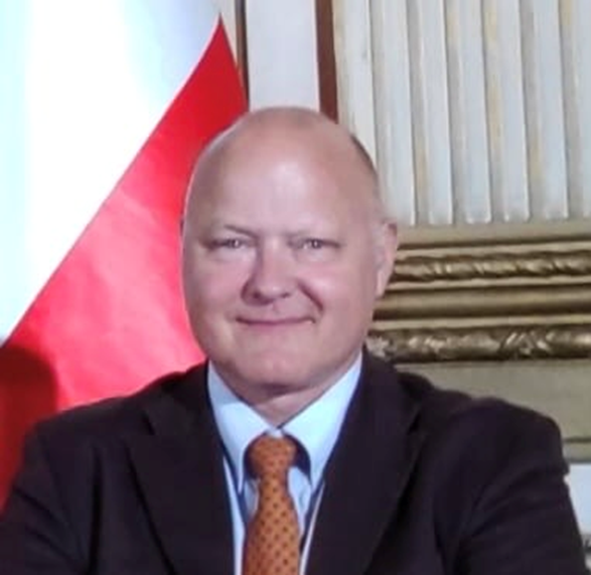
Stefan Hanslik
Stefan Hanslik is the chair of the e-Infrastructure Reflection Group. He is also national representative for Austria in both the steering and governing boards of EOSC and the EuroHPC Joint Undertaking. Stefan Hanslik is head of unit Technical Science at the Austrian ministry for education, science and research (BMWFW). Stefan has a Ph.D. in Biology/Genetics from the University of Vienna.

