Andy Götz | The role of thematic Research Infrastructures in the EOSC nodes ecosystem and beyond
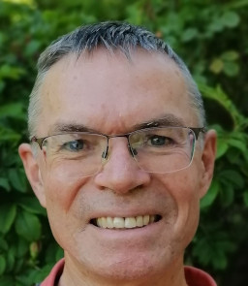 | Andy Götz joined the ESRF when it started in 1987 as software engineer where he has been ever since except for two sabbatical breaks. He has worked on control systems for the accelerators and beamlines at the ESRF, data processing and data management. He leads the Software Group at the ESRF since 2010. He has participated in a number of EU projects, where he recently coordinated the PaNOSC project. He is an advocate of Open Science especially Open Data and Open Source Software. He chairs a number of community-based open source projects, and regularly speaks at international conferences. He is a member of the International Union of Crystallography (IUCr) Commission on Data. He is currently also working part time at the EOSC-A on the federation handbook.

