Cathrin Stöver | Coordination of EU funding instruments
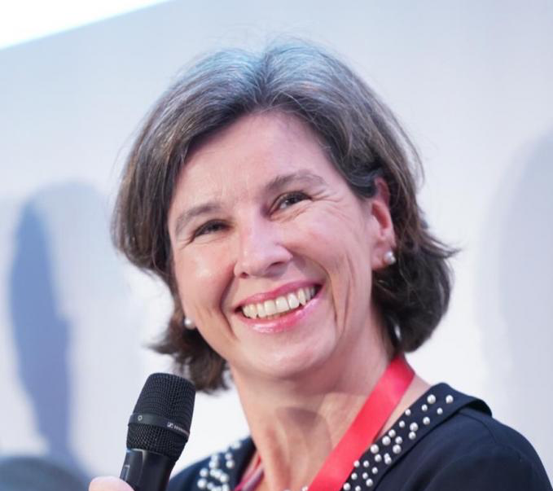 | Cathrin Stöver has belonged to the GÉANT team since 1997, holding various positions as the organisation has grown and developed, always with a specific focus on growing the geographic reach of the GÉANT network and the deepening of the global R&E collaboration for the benefit of the global research and education community. Since the beginning of 2020, Cathrin carries the overall responsibility for the Marketing Communications and Design teams as well as GÉANT’s EU Liaison Team. Between 2019 and 2020, Cathrin was Vice-Chair of the EOSC Executive Board. Cathrin was also a member of the SIAB of the Human Brain Project (2020-2024) and today is on the Scientific Council of the German NFDI.

