Javier Lopez Albacete - How Open Infrastructures influence valorisation - RDA Global Open Research Commons activities
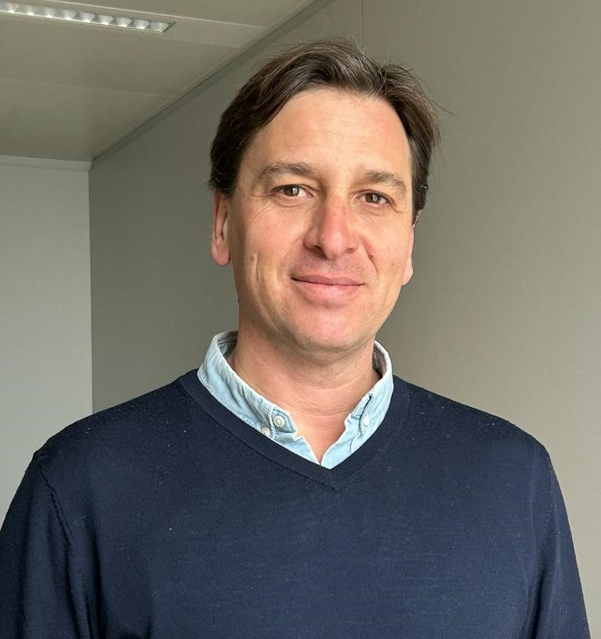 | Javier Lopez Albacete is Policy officer at the Open Science and Research Infrastructures Unit of Directorate General for Research and Innovation of the European Commission since 2021. Previously he served as scientific officer at the European Research Council, ERC.  In the framework of the RDA Global Open Research Commons (GORC) activities, he is acting as the co-Chair representing the “Europe” region.

